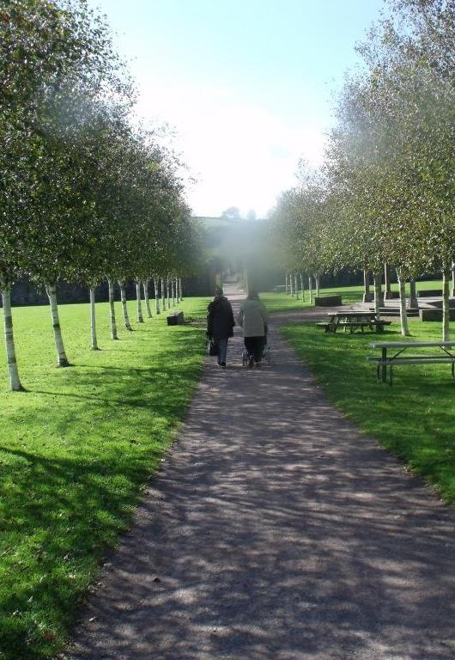
The Garden has a rich variety of trees that look beautiful in autumn.
Follow the numbers on this short trail and you’ll get to meet a few of them.
Betula utilis Himalayan Birch
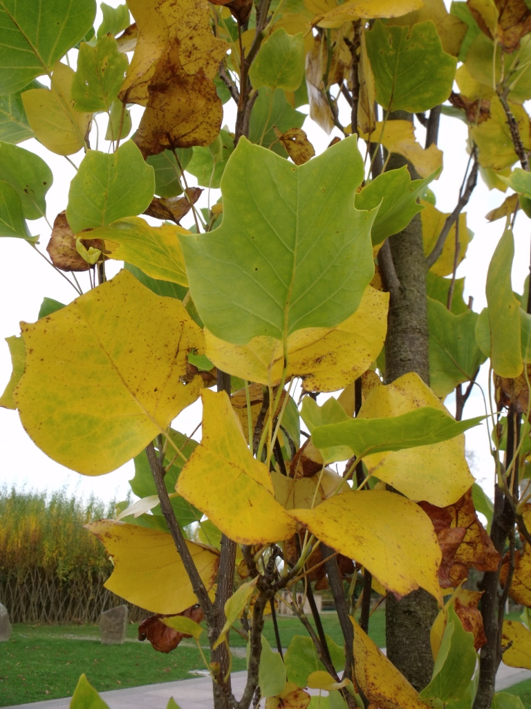
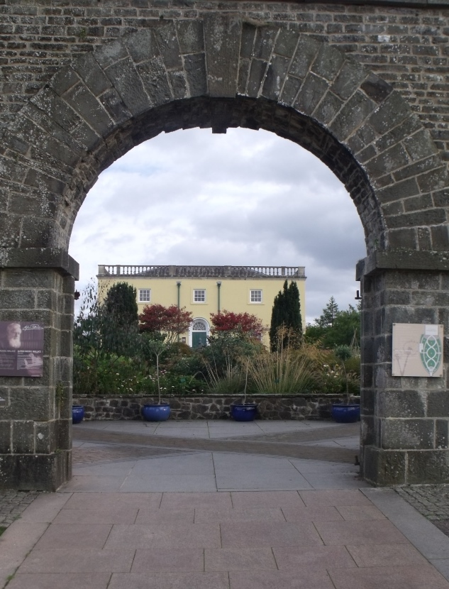
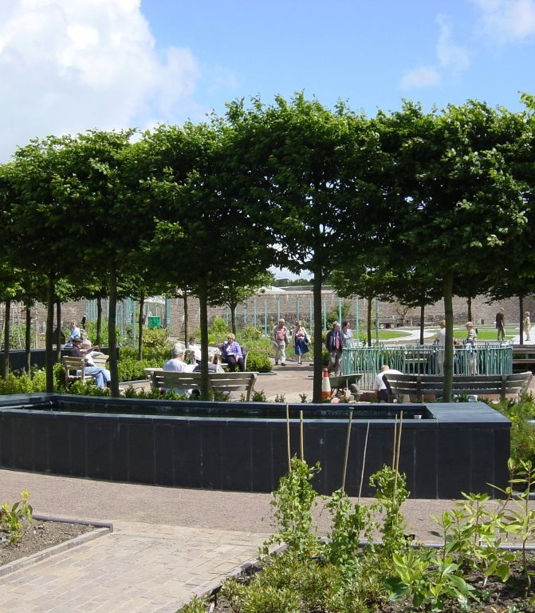
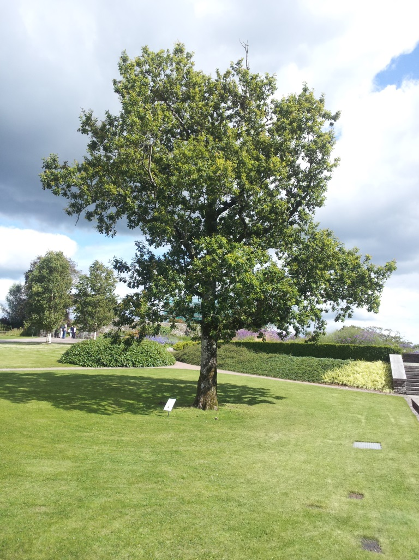
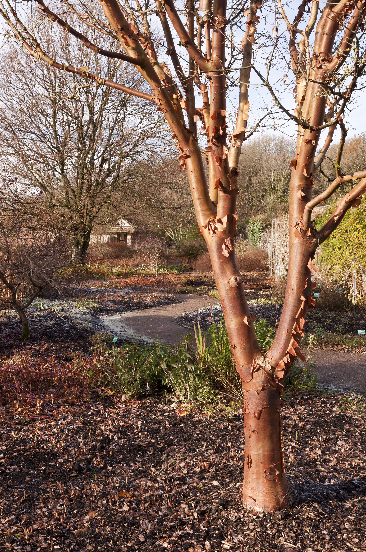
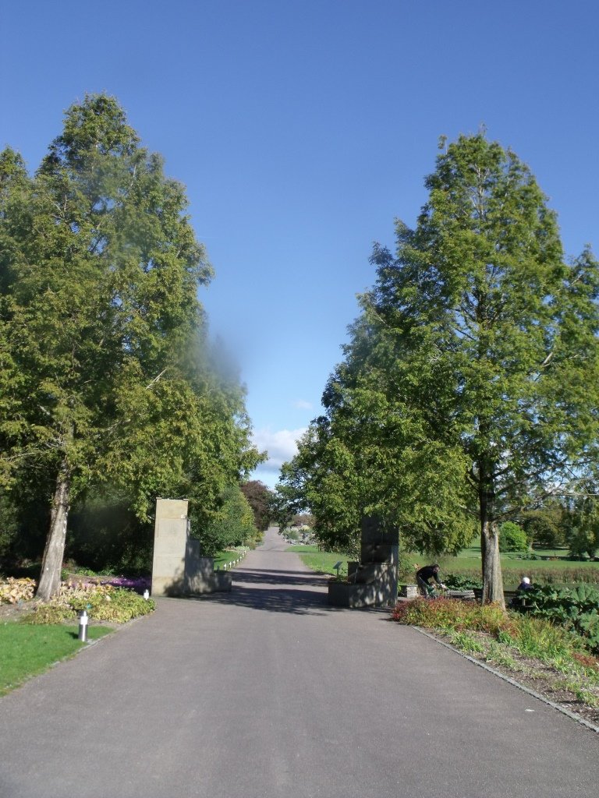
There’s a beautiful line of birches along the path in the Double Walled Garden. These have strikingly white bark and some fascinating fungi pop up around their bases in autumn.

Whereas British silver birch brushwood was used to make broomsticks, the bark of Himalayan birches was used in India to write ancient Sanskrit scriptures.
There are many mature hornbeams in the Garden - and a sculptured circle of hornbeams dominates the centre of the Double Walled Garden. Its leaves look like beech but with jaggardy edges. Seeds from its catkins provide food for the rare dormouse, which lives in woods around the Garden.
Carpinus betulus Hornbeam
B
The leaves of most varieties of Acer turn beautifully red and orange every autumn.
Japanese maple is possibly the most beautiful of the maples and we have two great examples at the top of our Wallace Garden. These are ‘Atropurpureum’ cultivars, noted for their wine-red autumnal colours.

Acer palmatum Japanese Maple
C
This 70 year old oak tree won the Welsh Tree of the Year in 2015!!! Why? The sign next to the tree will tell the full story.
There are two native species of oak in Wales. Acorns on pedunculate oaks have a short stem whereas sessile oak acorns have no stem.
Have a look at the acorns on this oak tree to work out what species it is.
E
A native of eastern USA, tulip trees are fast growing trees that can reach great heights.
They have distinctive leaves which turn a beautiful golden colour in autumn.
We’ve recently planted two tulip trees to ‘frame’ the pathway from our Stable Block to the Wallace Garden.

Along the Broadwalk, you’ll find this amazing looking tree which is native to central China
Its copper orange bark peels into large curls which remain on the tree rather than falling onto the ground. This contrasts with its rose brown inner bark, and orange to red autumnal leaf colours.

D
Quercus robur Pedunculate Oak
Liriodendron tulipifera Tulip Tree
Acer griseum Paper Bark Maple
Until 1941, this tree was thought to be extinct.
It was first known as a fossil then a huge tree was discovered growing around a religious shrine in China. Seeds from this tree were collected and it is now a popular ornamental tree in parks and gardens around the world.
You can find a circle of dawn redwoods surrounding our Scaladaqua Tonda water sculpture on the Broadwalk.

Metasequoia glyptostroboides Dawn Redwood

C
5
2
7
6
1
4
3
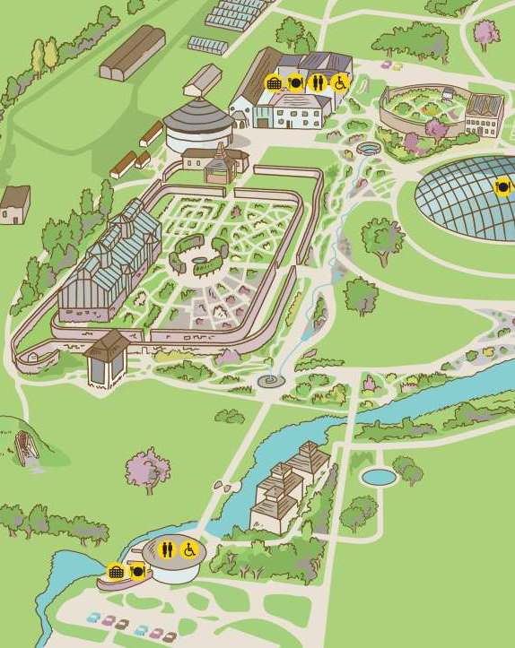
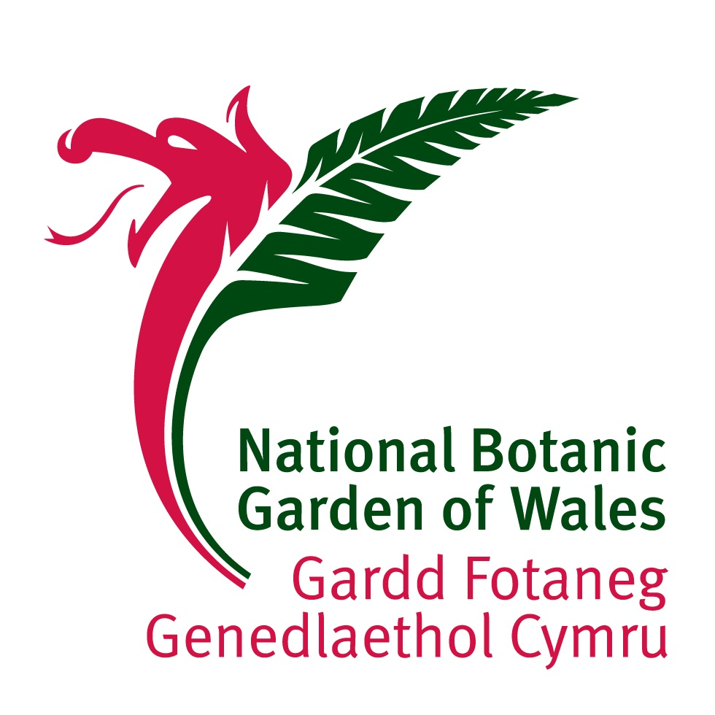
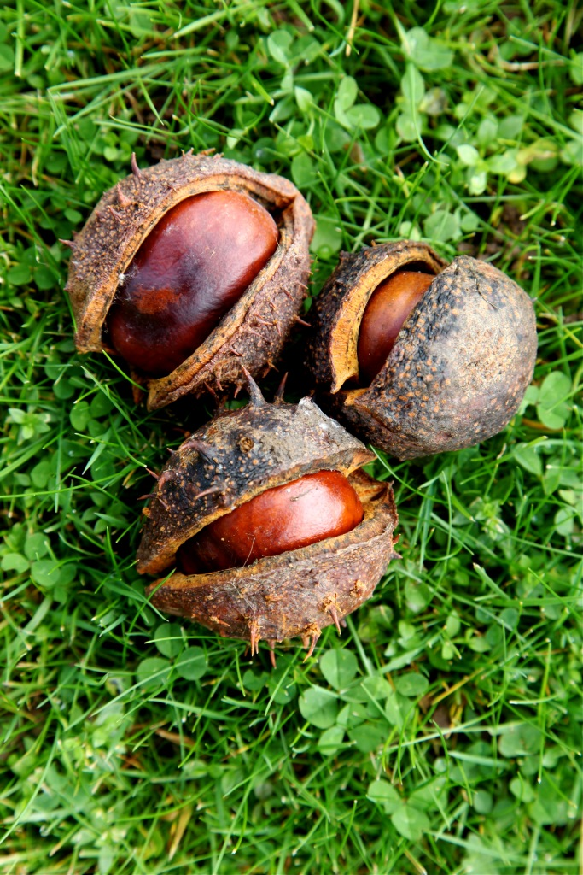
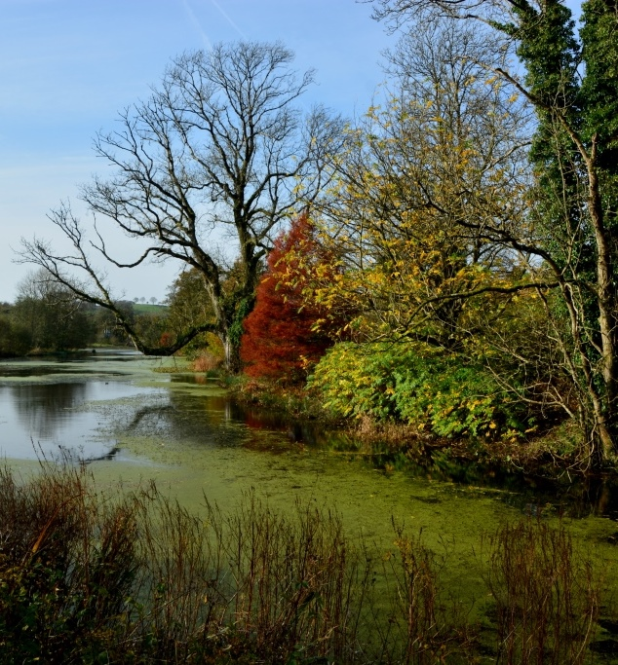
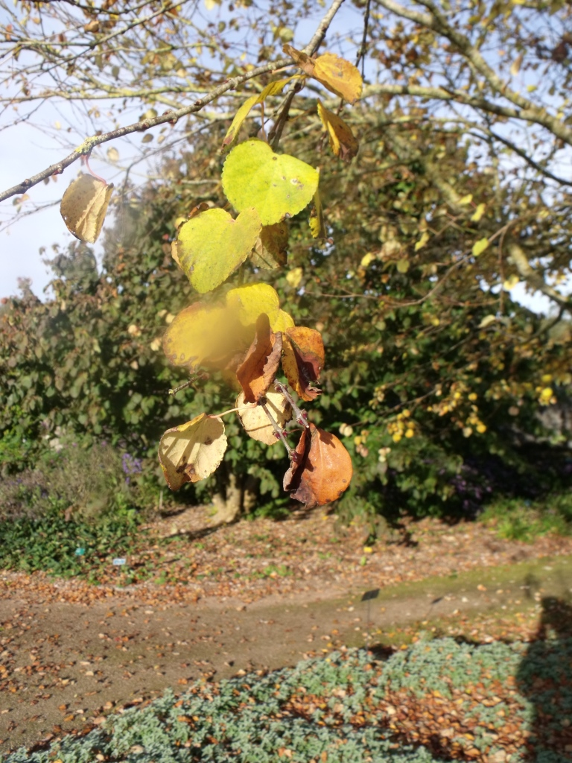
7
2
8
4
3
1
5
9
6
10
Playing conkers is a traditional children’s game that is played less as children play less outdoors. We collect conkers from the Garden’s 3 horse chestnut trees for our autumn half term family activities week – our Bonkers Conkers competition is really popular.
Horse chestnuts were introduced to Britain from the Balkans in the 1600s,
H
I
J
Autumnal Tree Trail

Aesculus hippocastanum Horse Chestnut
Not only does this tree produce attractive orange, yellow and red autumnal colours along the Broadwalk but its fallen leaves produce a nice smell too. What is that smell? Some think its caramel, others go for candy floss. What do you think?

A native of China and Japan, the katsura tree can grow up to 45m tall.

Cercidiphyllum japonicum Katsura Ash
If you go along our lakeside paths in autumn, you may discover some spectacular displays of autumnal leaf colour.
We have a variety of tree and shrub varieties there, with wingnuts, cherries, witch-hazels and this bald cypress tree being some of the most beautiful.
Ancient bald cypress forests once dominated huge areas of swampland in Florida.
Taxodium distichum Bald Cypress Tree

Broadwalk
Double Walled Garden
Great Glasshouse
Gatehouse Entrance
J
H
9
10
8

