Building report for Waun Las Farm house and Outbuilding

Carried out on the 5th of September 2018
By Emilia Hawthorne

Contents

Background Information

Description

Photographs

Conclusion

Background Information
An armature photographical survey was undertaken on Waun Las Farm to record the farm house and outbuilding before they fall into further disrepair. This report outlines what was found from that survey.
The survey was undertaken in sunny conditions in the afternoon of the 5th of September.
The farm house and outbuilding is owned by the National Botanic Garden of Wales.
The front of the house faces south and back of the house faces the North.
It was built by Carmarthen County council in the 1930s, and was to be a starter farm.

Description
Age; Waun las is about 80 years old, it was constructed in the 1930s
Type of property; the farm house is a detached 3 bedroomed house, and the outbuilding is a cow shed.
Location; Waun Las farm is located within the National Botanic Garden of Wales just beyond Llyn Mawr and Lyn Canol lake. Roughly 10 miles from Carmarthen. As of 2008 it is currently a nature reserve.
Farm House
Layout; in the farm house there is a ground floor and a first floor. The ground floor has 3 original rooms (lounge, dairy and parlour), and a later added extension that houses 3 small rooms- a bathroom pantry and toilet. The first floor has 3 bedrooms, (see figure 1). There is also a small attic (the attic was not recorded).
There are also two outbuildings that accompany the house; it is assumed they were a coal house and outside toilet. They are to the east of the property. (See figure 3)
Chimneys’; the house has two chimneys, one on the east and one on the west of the house. The chimney on the east has a fireplace in the lounge (see figure 4), and a cast iron fireplace in the above bedroom 1 (see figure 4). The chimneys to the west of the house has a blue Rayburn cooker in the parlour (see figure 5) and in the above bedroom 3 there is a cast iron fireplace (see figure 6).
There are no chimneys on the outbuilding.
Damp; there is evidence of damp in bedroom 1 and the lounge. In bedroom 1 were there is damage to the roof which means when it rains water can get into the room (see figure 7). This is causing the damp.
Ceilings; the ceilings are mostly plaster board and covered with white floral wallpaper. (see figure 19)
Floors; ground floor is red stone tile flooring (see figure 8), with the lounge and parlour having carpets put in over the top of the red stone tiles, (see figure 9). The first floor floors are made of wooden planks covered by carpets or vinyl (see figure 13).
Joinery; there are modern plastic, double glazed windows (see figure 10). In the parlour there was a green bench seat that was attached to the wall (see figure 11). There were no cupboards in the parlour. The dairy had two shelves painted blue behind the door (see figure 20).
Decoration; the house was painted primarily in pink and had wallpaper throughout (there were many different types of styles of wallpaper, see figure 5). There is a lot of wallpaper variety across the whole house.
Roof; the roof on the south facing side has slates missing so water is getting in. There are wooden beams which the roof tiles side on.
Outbuilding/ cowshed
Layout; ‘L’ shaped building with 4 doors in the main room. The cow shed has one main room where cows were put when they were being miked. At the entrance to the main room there is a wooden ladder which Leeds up a first floor room that was probably used to store hay (See figure 2).
Ceiling; for the outbuilding the ceiling there is wooden rafters.
Floor; the floor is made of concrete throughout the outbuilding.
Decoration; all walls have been painted white and majority of the doors painted red (see figure 12).
Joinery; windows (single pain) are also painted red. Some have been blocked as can been seen in figure 18.

Changes seen from the 1963 plans
The back door is also different in the plans as it appears that there was an open porch, but is currently a closed off porch that you enter through a blue door.
In the 1963 plans of Waun Las farm house suggested blocking off a door in the lounge and created a cupboard underneath the stairs. These plans were done because the cupboard is there today.

Photographs
Figure 1 plan of farm house,

Bedroom 2

Bedroom 1
Bedroom 3
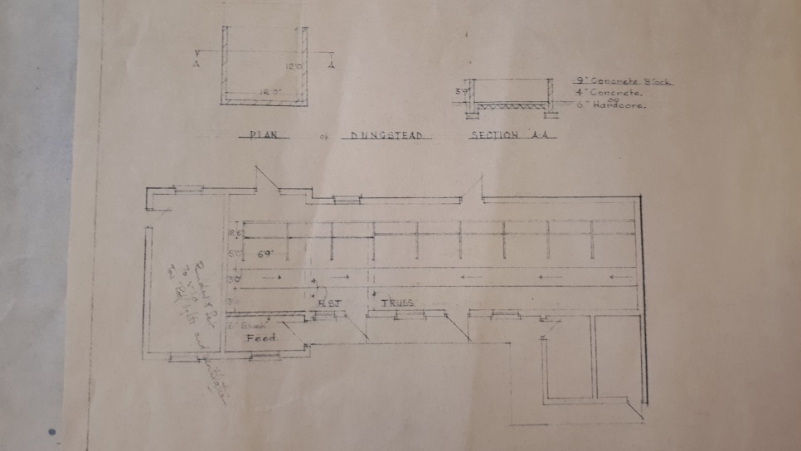
Figure 2, showing the outside, and inside main room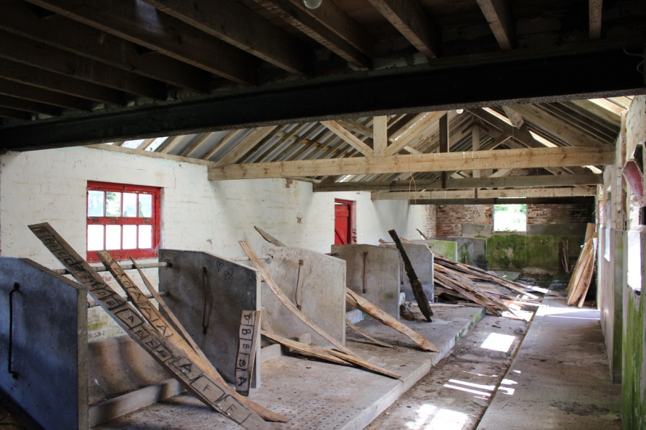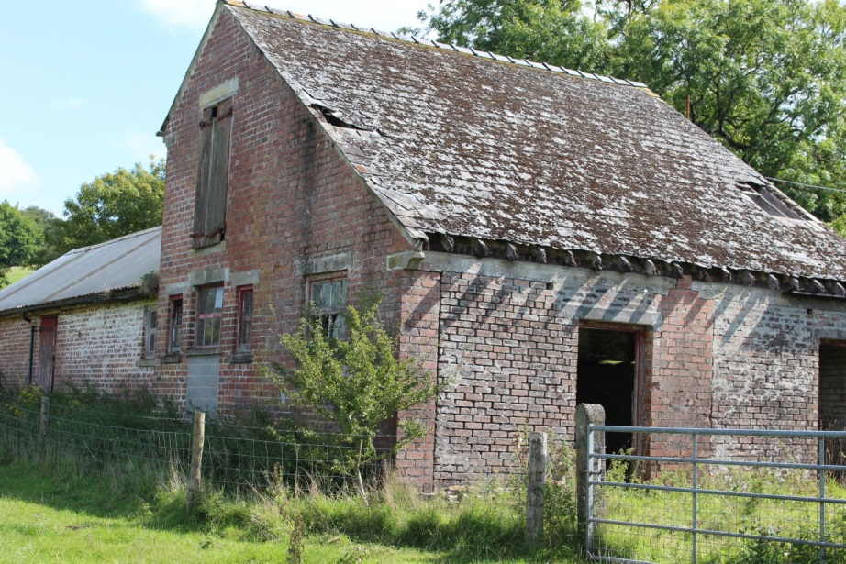

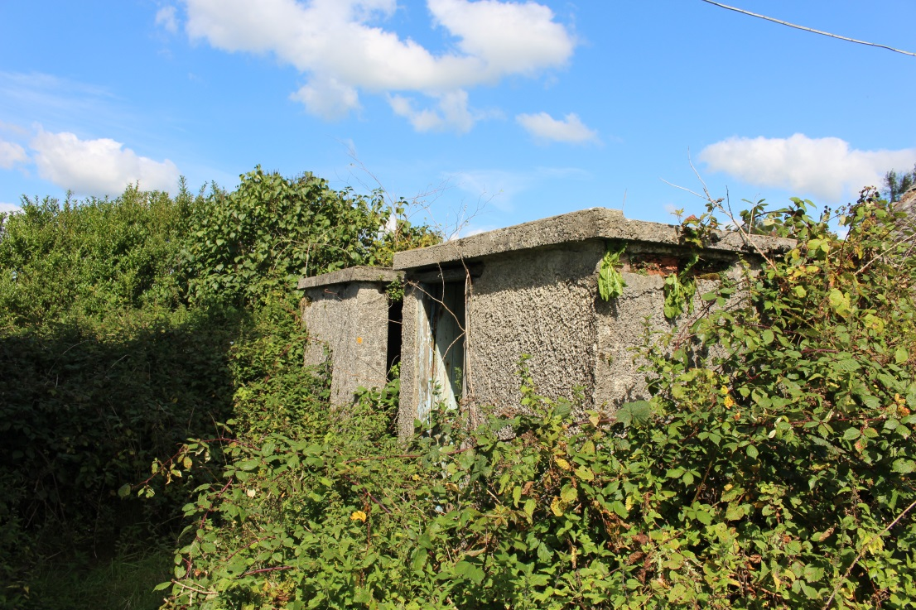
Figure 3, the farm houses’ outbuildings,

Figure 4, the lounge fireplace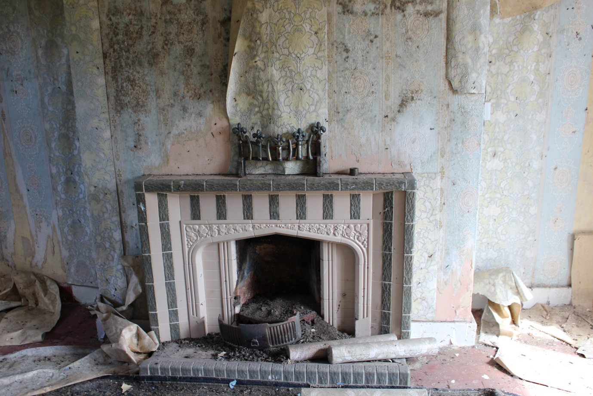

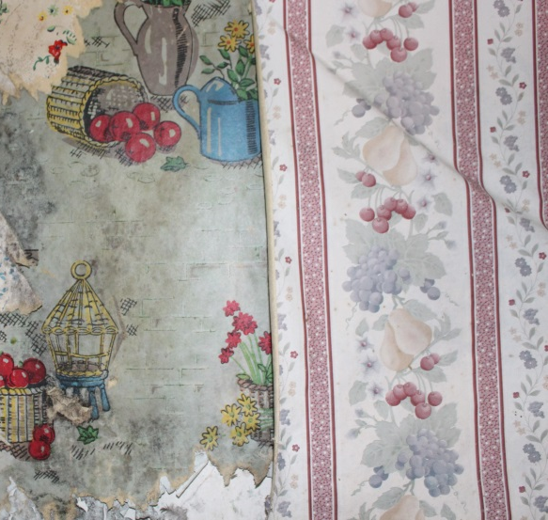
Figure 5 bedroom 1s’ cast iron fireplaces, 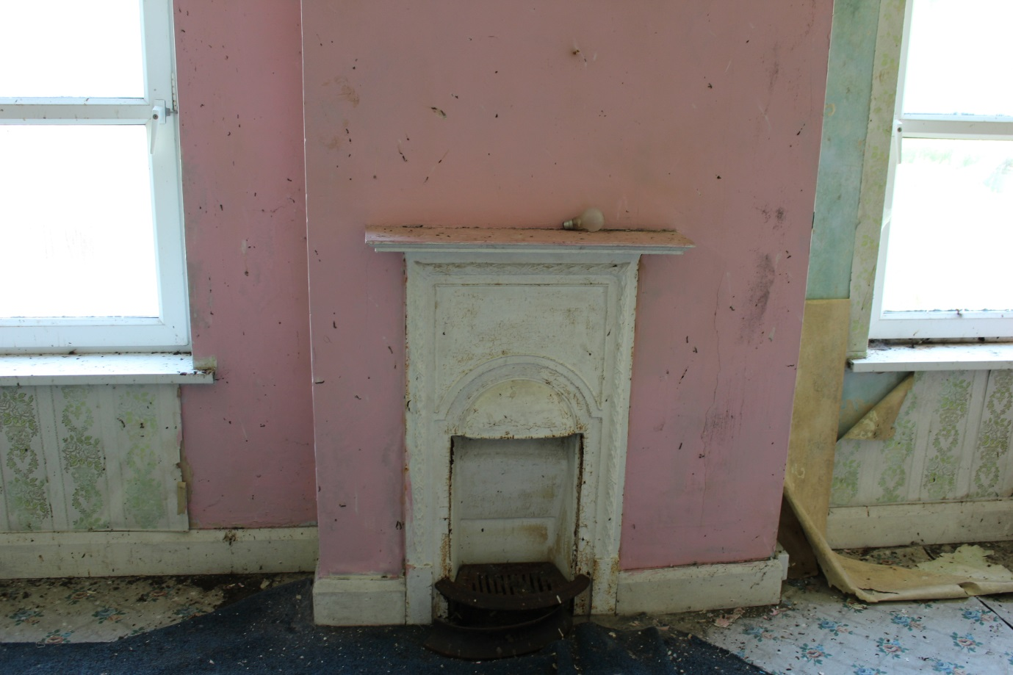
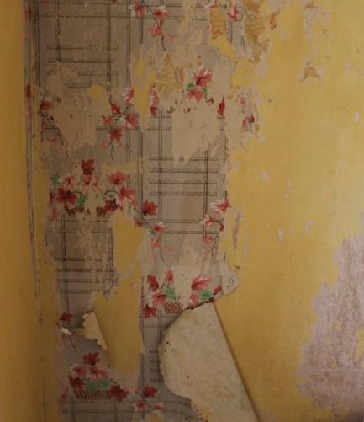

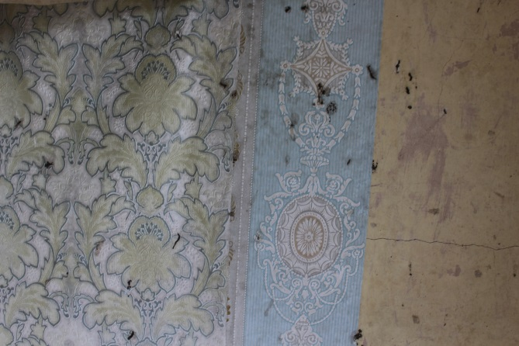
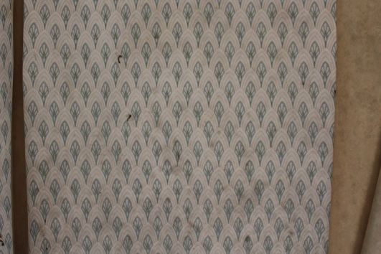
Figure 6 parlour stove 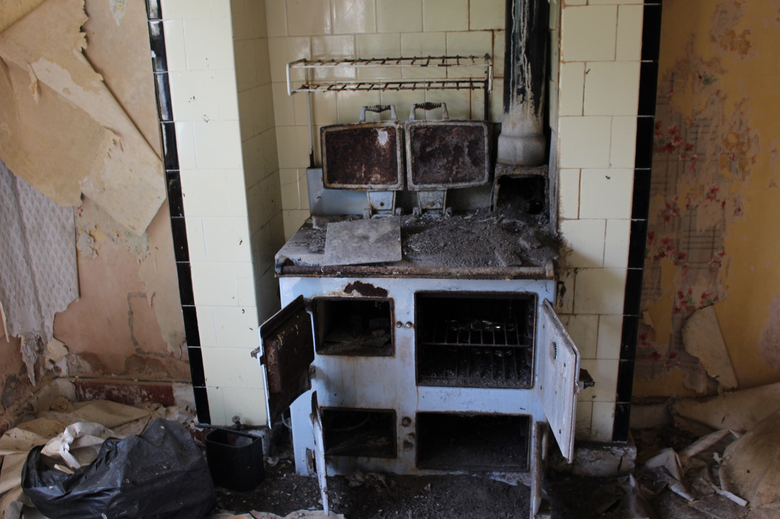
Figure 7 bedroom 3s’ cast iron fire place
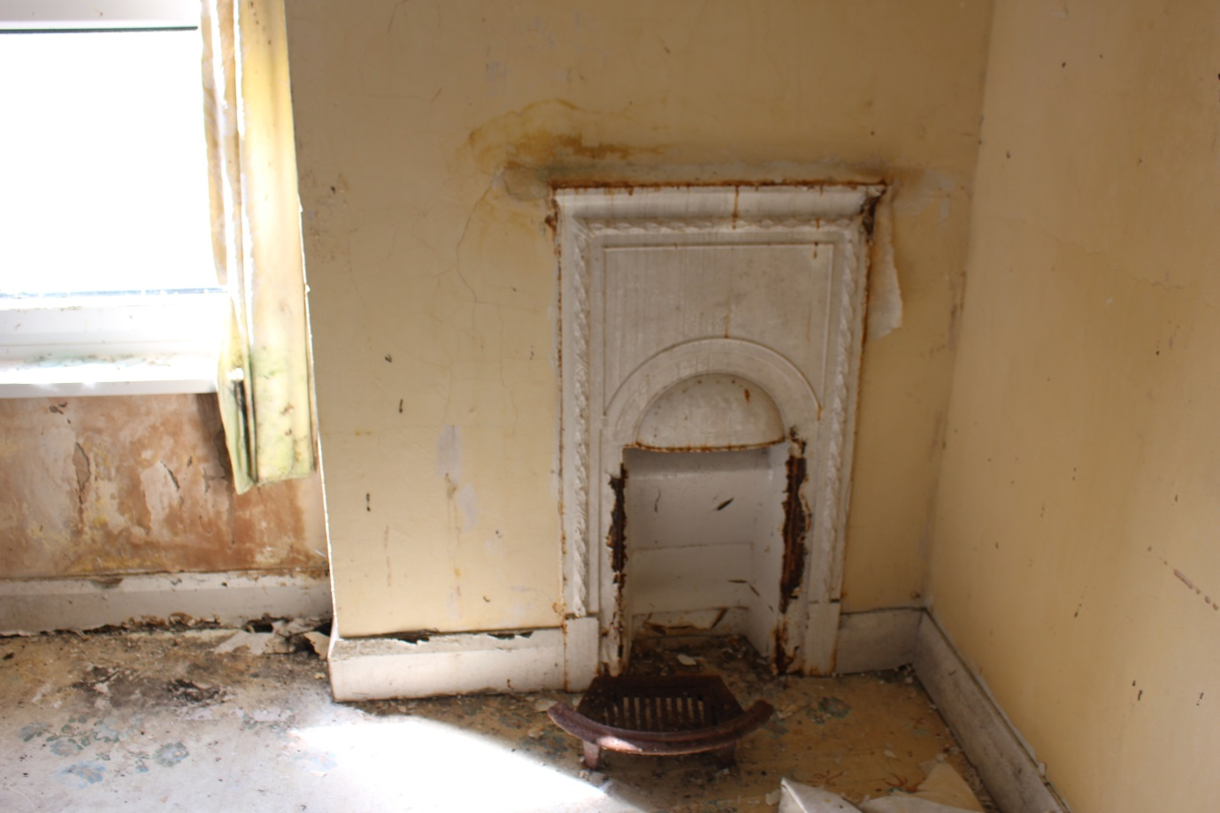
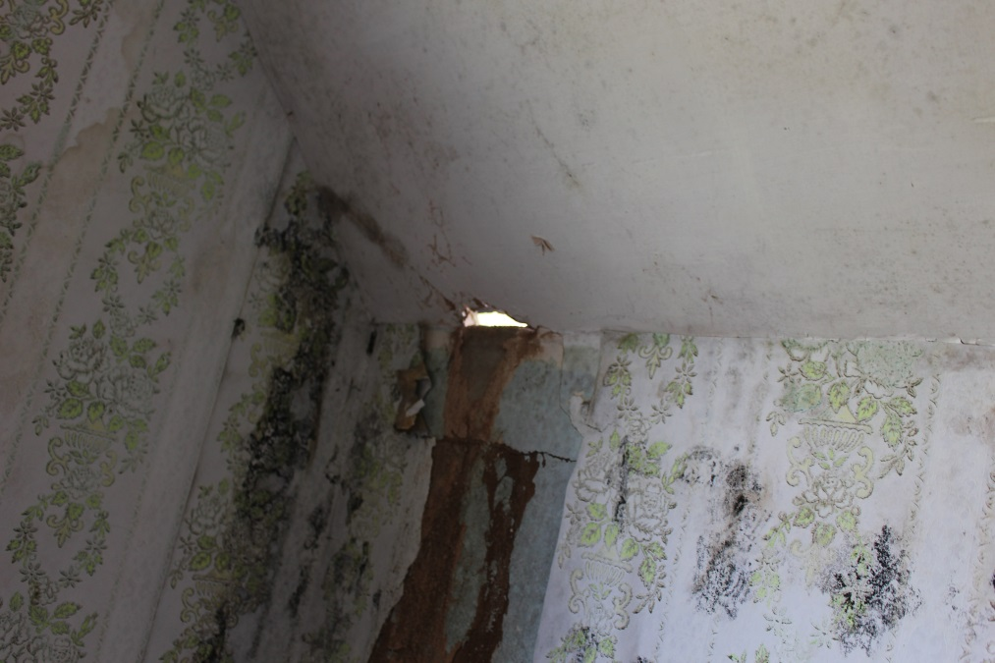
Figure 7, shows the damaged ceiling I bedroom 1

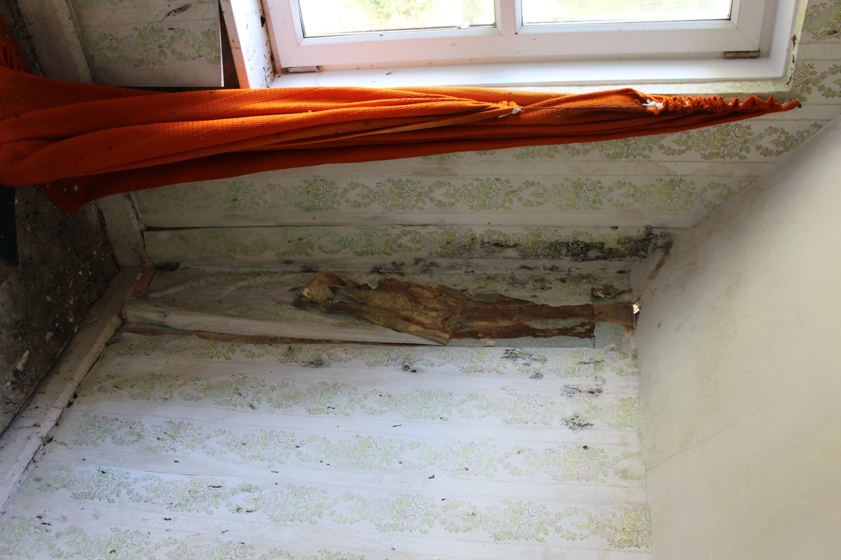

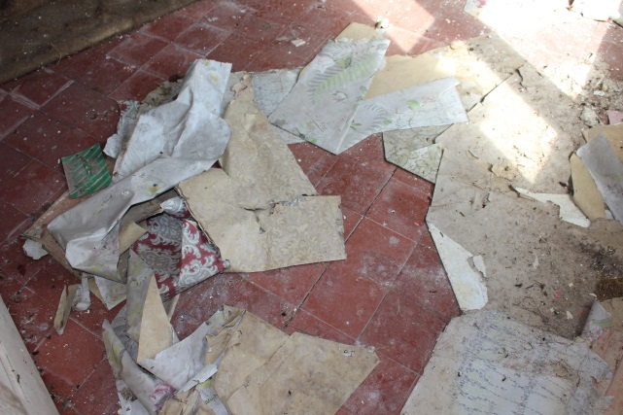
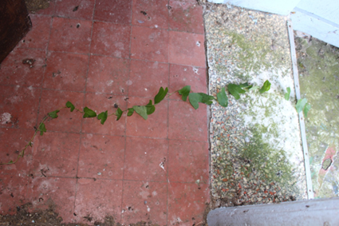
Figure 8, shows red stone tile flooring;

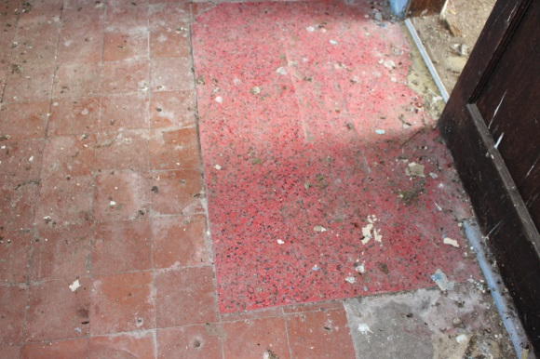

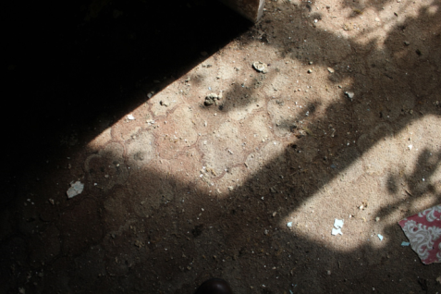
Figure 9 shows carpet on top of red stone tiling in parlour and lounge

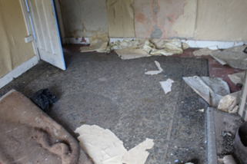

Figure 10 shows the modern windows in the farm house
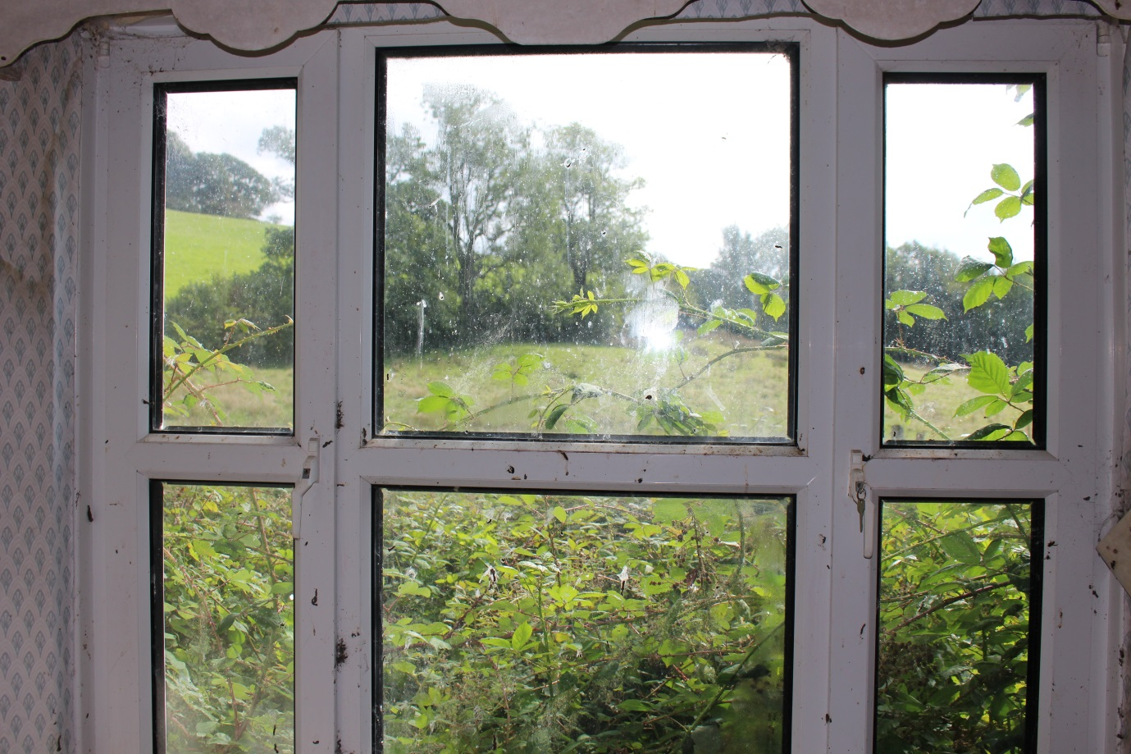

Figure 11 showing the bench seat in the parlour

Figure 13 showing wooden floors covered by carpet/vinyl
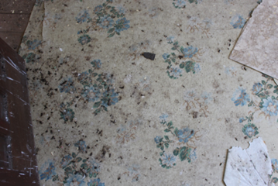
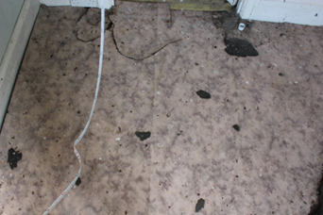

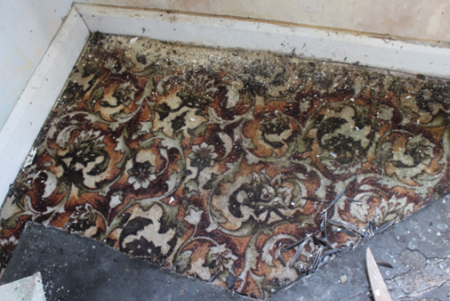
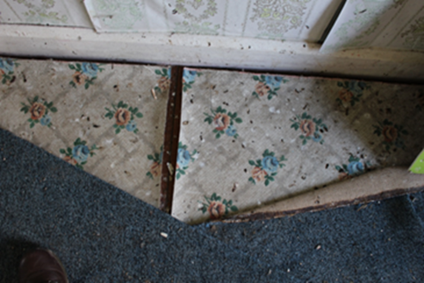

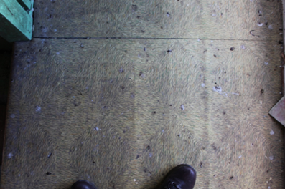

Figure 12, showing white panted inside of the outbuilding
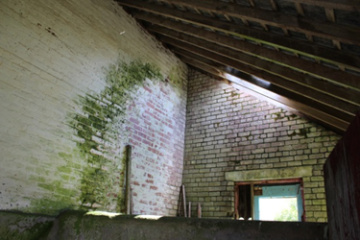

Figure 18 showing blocked up windows
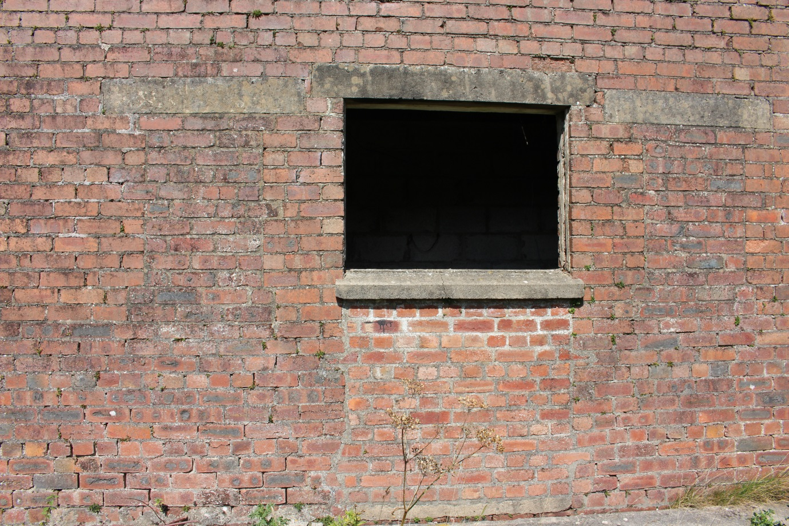

Figure 19, shows floral ceiling wallpaper
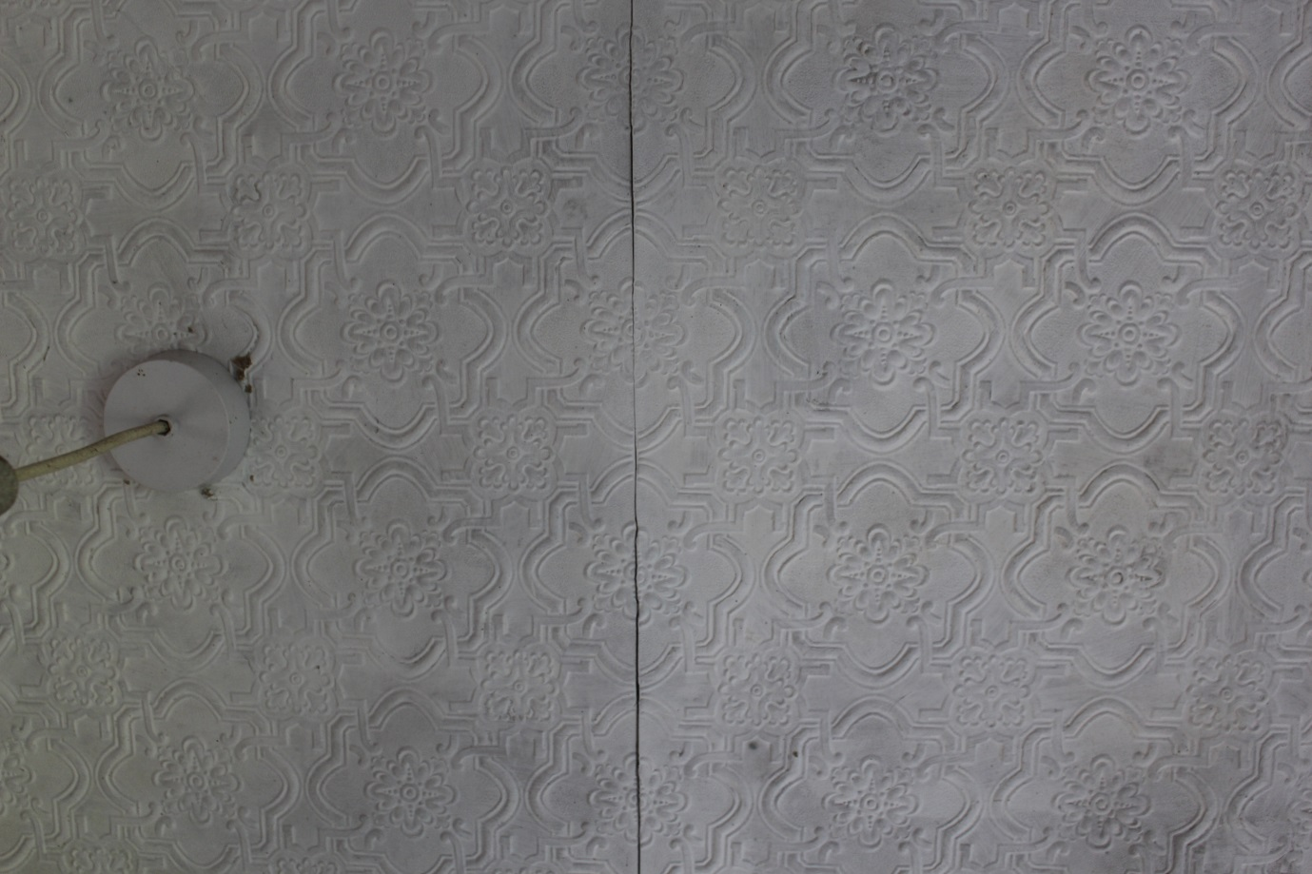

Figure 20, showing blue shelves in the dairy
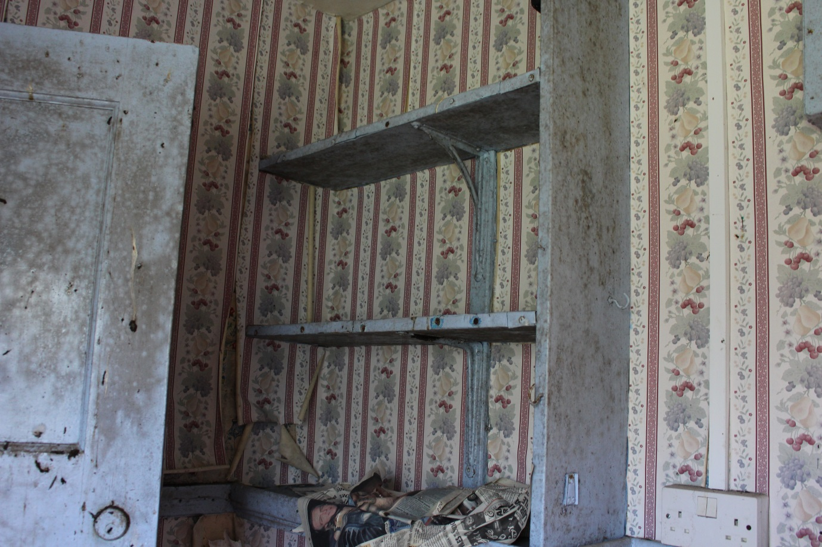

Conclusion
Waun las farm house is in need of a refurbishment as the decoration is outdated, wallpaper is peeling off the walls and there is bird excrement all over the walls floors and doors. There are missing slates on the roof which is causing the leak in bedroom 1. The windows seem to be in good condition if not a bit of rust were the keys have been left in the lock.
Unfortunately there has been no access to census records so I do not know who lived at Waun Las in the past.
This farm house is twinned with over farm houses and outbuildings on the estate, for example Pantwgan has exactly the same principal structure and layout but has since had changes to it such as the extension to the back of the property and bedroom 2 being converted to a bathroom. There were another two farm buildings that the original buildings are exactly the same, (Alt Goch and one over).

