Interesting Information

Middleton= 1600 – 1790s
Paxton= 1793 – 1824
*House Auctioned on the 19th of August 1824*
Adam/Abadam= 1824 – 1919
*1843 a fire broke out on the estate which was believed to have been started by arsonists. The house was not damaged*
Col. Jones= 1919 – 1933
*House was let out to Lloyd family in 1919, who were pig-keeper caretakers*
*1st November 1931 a fire destroyed the house*
County council= 1933 - 1990s
*house demolished in 1954*
Botanic Garden= 2000 – present

Old Middleton Hall
It was registered that the original hall had 17 hearths and from excavations the house was built to the popular ‘H’ plan layout. In 2011 and 2012 small scale excavations took place to identify the original house and the original garden which had a rectangular pond (which shows evidence of a water fountain in it), amongst over water features. The house was almost defiantly demolished by 1800 so that it didn’t affect the new house Paxton was creating. There is an area of the estate that was not investigated and according to Austin and Thomas should yield very significant results and enhance a greater understanding of the garden around the original Middleton Hall.
David Middleton who created the house, Father Richard was governor to Edward 6 Mary and Elizabeth Tudor
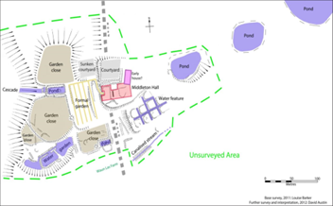
(Figure 1, showing an interpretation of the old Middleton Hall deuced form the 2011/12 excavations.)
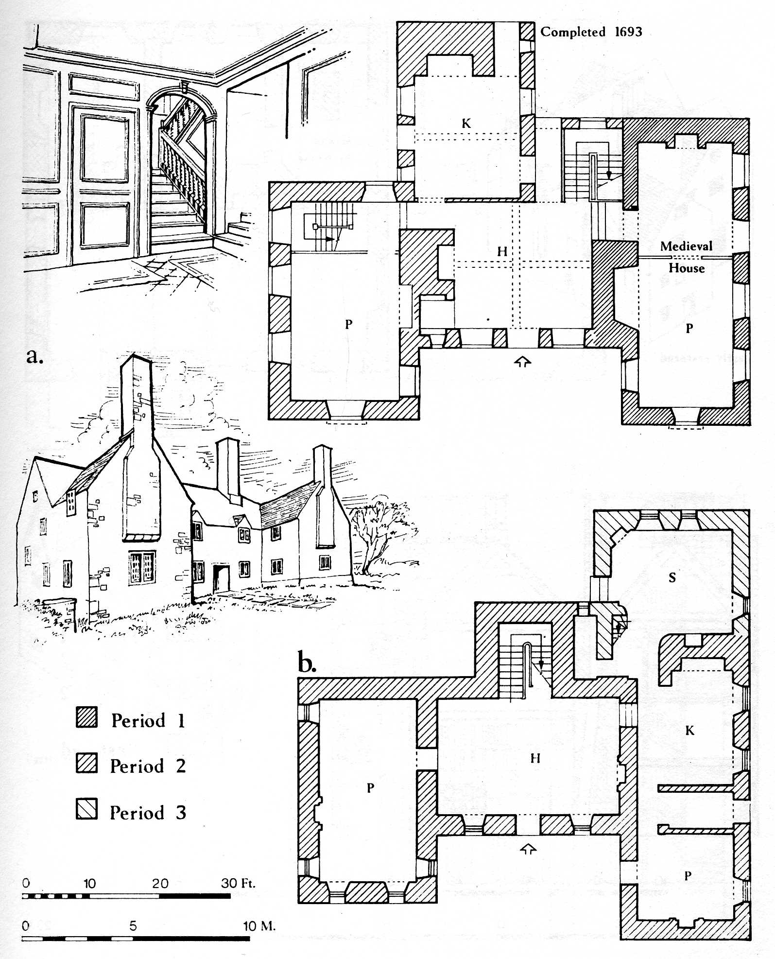
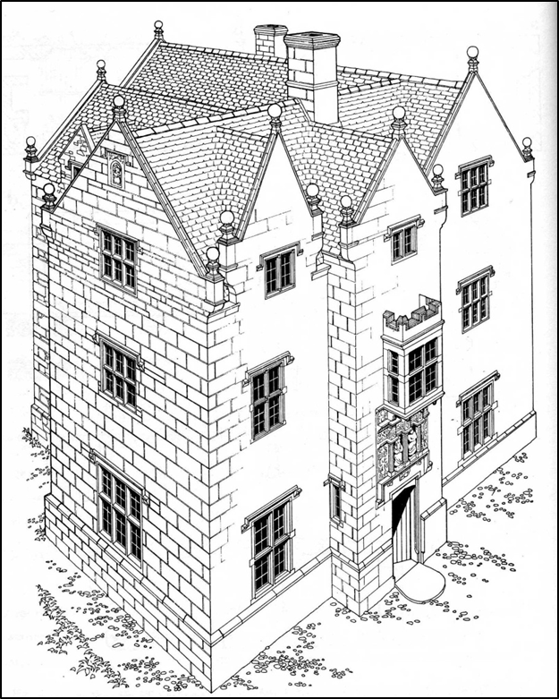

(Fig.2 is an interpretation as to what the original Middleton hall might have looked like.)

When the male line became extinct and the female Middleton’s’ married the house was sold and converted into farm buildings
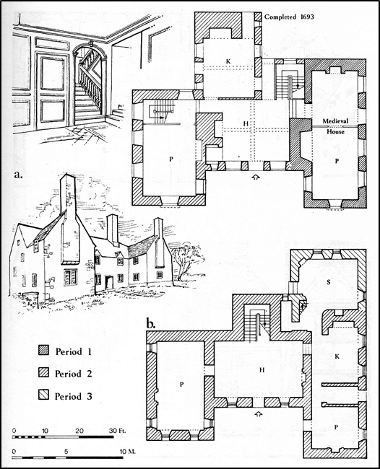
(Fig.6 Arial photo of Waun Las with illustrations of the finds interpretation)

Paxton’s Middleton Hall
In stable block they housed 22 horses
Office building had its own cheese room
House built by Mr. Cockerel and Paxton’s tower plans were drawn up by Cockerel
Paxton spent £15,690 on the election in which he lost by 107 votes. 25th may 1903 the Bishop Owen moved into Middleton house for two months whilst his other house was being constructed. In 1902 lieutenant Hugh returned home to Middleton Hall were 600 – 700 local people welcomed him home, and they sung ‘God save the king’, and ‘Hen Wlad fy Nhadau’
Paxton and his family support a charitable school that taught poor children and ran because of their money that they put towards it.

Abadam/Adam
Mr. Adams was born in Jamaica in 1777, and married January, 1796, Amelia Sophia, eldest daughter of Captain John MacPherson, of the United States.
July 1840 2 labours (William Thomas and John Evans) stole 2 bundles of hay at 2 shillings each from the Middleton estate each labourer was sentence to do 18 months labour work.

1843 September there was a fire at Middleton hall, stacks were on fire in the farm-yard and once Adams arrived home he set about rescuing what documents were vital to him and called upon the military to help protect his property but they were not dispatched. And it was thought that the fire was started by arsonists who had also drained the fishpond so that they could not use that water to put out the flames. The newspaper also states that there were armed men in the woods around the house. Two ricks were site on fire which had 60 tons of hay (cost of £200)The damage is said to cost about £300 the house was not damaged but the family moved to Carmarthen for safety.
A Dr. Saunders tested the water at Middleton Hall and listed all its properties and suggested that it has medical properties the same of which he uses. This is also discussed in another newspaper article and says that the Chalybeate spring has the same properties of Tunbridge Well’s spring. In 1846 Mrs Adams gave to the local parish church a velvet cushion and a pulpit cloth.

1848 Thursday 23rd November a Mr Downs shot himself in the foot near Middleton Hall and Mr Adams went to the seen to help.
1848 There was a carriage accident involving Mr and Mrs Abadam their two children and a servant. The carriage swerved to avoid an oncoming carriage means their carriage was sent into the verge and occupants flung out. Mrs Adams sustained a fractured collar bone and the overs sustain bruises. The cost of damage to the carriage costs between £40 - £50.
In September 1848 Edward Adams took on of his tenants to court as they were not vacating the property he won the case and the tenant had to leave.
By 1855 Edward was High Sheriff in Carmarthen.
Edward Abadam gave a dinner to his tenant and work men Jan 1856.
1852 ‘D. Davies, and Grismond Philipps, Esqrs. David Rees, blacksmith, and David Dalies, mason, were charged with trespass in pursuit of game upon the Middleton Hall estate. Fined £ 1 1852’
1868 These items went missing and the rein were found on the prisoners position, the prisoner had been in the employ of Abadam, ‘one breaking collar, One horse collar, one breaking head piece and bit, one bride rein, one martingale, and one kicking strap, are the property of Mr. Abadam and are worth ten shillings at least’ From the evidence it appeared that the prisoner had been in Mr. Abadam’ s service for about five weeks as a colt- breaker. He left the service three weeks ago, and several articles, valued at 10s. Were missed. The articles were found in a house where prisoner was staying. There was a quantity of evidence taken, and ultimately the prisoner confessed having stolen the whole of the articles, and he was committed to the House of Correction for two months with hard labor.
A defendant was tried for stealing Mr. Abadam gun and selling it. 1868
1870s Lawrence marries into the Abadam family and runs estate.
Mrs. Abadam eldest son and husband both died of gunshot wombs in America in 1873.
1873 a former employee at Middleton house Elizabeth Michael sued David Clarke for owing wages.
Mrs. Lawrence Abadam reduced the rent by 12.5% much to the pleasure of the tenants who did not ask for it 1886.
The Lawrence’s sent 18 gallons of bear and 2lbs of tobacco to the inmates at local prison at Christmas time 1885.
1889 Lawrence sent a sack of apples to inmate.
1889 Miss Abadam lead a choir in the local church.
Scarlatina broke in villages around Middleton Hall 1883.
In celebration of the royal marriage of High Sheriff of Glamorganshire Middleton hall opened up to paupers. July 1893
1894 – Mr. and Mrs. Lawrence showed members of western rail and London around an area that they proposed would be a good place for a railway.
Elma eldest daughter of the late Conrad Maxell Middleton Abadam to be married April 1894
Miss Geraldine Mabel Abadam married in 1895
There is information about the interior of the house by Alice Abadam in a book about Llanarthney. She describes the green colour of the dining room, the bell that was used for workers to know the time and going on the roof to watch the sunset. It was also stated that the horses that died were buried in Waun Las field. The children also had ponies that they used to ride around the estate. Alice also states that there was a bell in the servant’s quarters that rang at 6am 1pm 2pm and 6pm to assemble workers and notify then of key times through the day
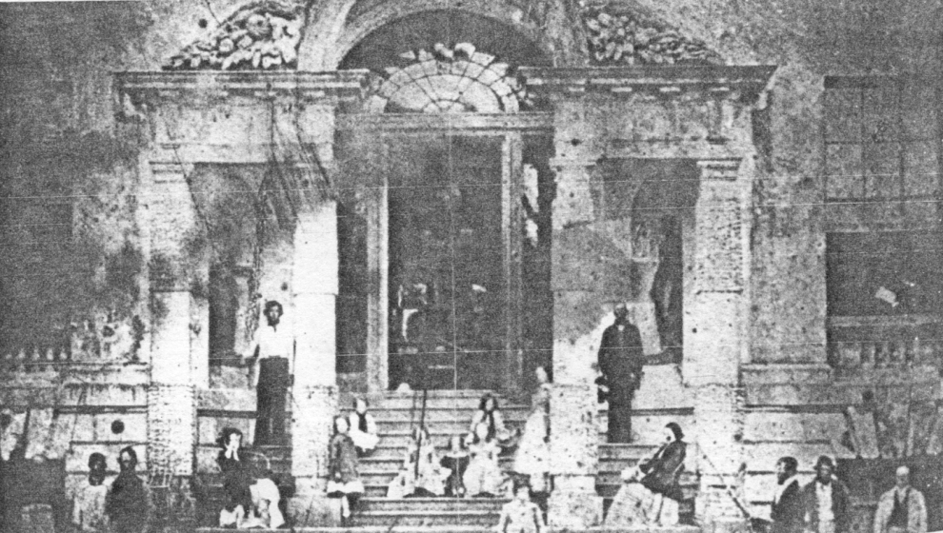

‘In 1919 Col. William Nathaniel Jones of Dyffryn, Ammanford bought the Estate from Major ………caretaker, Mr Hilbert Lloyd, and his family who farmed pigs, while the rest of the land was tenanted………. The County Council converted the outbuildings, including the servants’ block which was the only element of the mansion house to survive the fire, and built new farmsteads to create seven individual starter farms to encourage young people to enter the agricultural industry. The estate became a thriving community which continued through to the 1990s.’

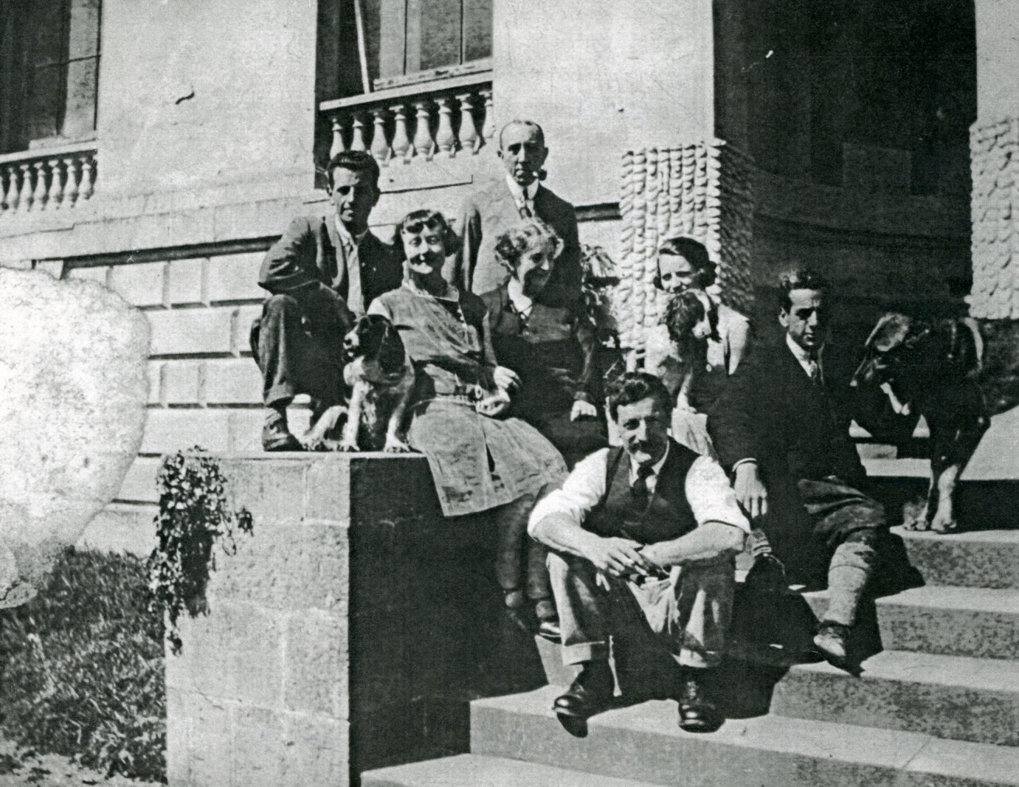
Lloyd Family 1930s
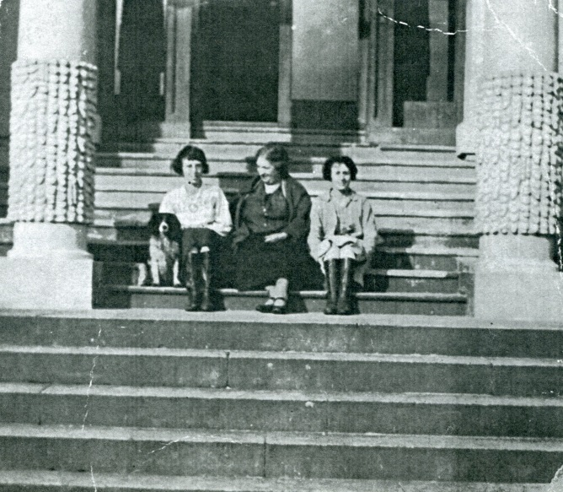

There were plans for a hotel in the science block
Useful website; http://landedfamilies.blogspot.com/2013/02/1-abadam-of-middleton-hall.html
About Alice Abadam; https://thesibylblog.com/violet-pagets-cousin-alice-abadam-an-active-suffragist-by-jill-davies/

Sales brochure of Middleton Hall page 1
D. Austin and R. Thomas, 2013, A Garden before the Garden: Landscape, History and the National Botanic Garden of Wales, pages 39, 40, 42, 43
http://newspapers.library.wales/view/3376188/3376194/107/Middleton%20Hall
D. Austin and R. Thomas, (survey by L. Barker), 2013, A Garden before the Garden: Landscape, History and the National Botanic Garden of Wales, page 41
X:\Middleton\Marketing Images-Middleton Hall
Middleton Hall, Caermarthenshire; the seat of Sir William Paxton page 20
https://www.casgliadywerin.cymru/items/386449 [Accessed 31.08.2018]
http://newspapers.library.wales/view/3376188/3376194/107/Middleton%20Hall [accessed 03.09.2018]
The Cambrian, Swansea, 1818
http://newspapers.library.wales/view/3429683/3429684/9/William%20Paxton%20Middleton%20Hall%20AND%20Middleton%20Hall%20Carmarthenshire
http://newspapers.library.wales/view/3329860/3329863/13/William%20Paxton%20Middleton%20Hall%20AND%20Middleton%20Hall%20Carmarthenshire [accessed 04.09.2018]
http://newspapers.library.wales/view/4345909/4345911/18/William%20Paxton%20Middleton%20Hall%20AND%20Middleton%20Hall%20Carmarthenshire [accessed 04.09.2018]
http://newspapers.library.wales/view/3632895/3632898/16/William%20Paxton%20Middleton%20Hall%20AND%20Middleton%20Hall%20Carmarthenshire [accessed 04.09.2018]
The Carmarthen Journal, Stocks this day, 1810
http://newspapers.library.wales/view/3323975/3323978/10/William%20Paxton%20Middleton%20Hall%20AND%20Middleton%20Hall%20Carmarthenshire [accessed 04.09.2018]
http://newspapers.library.wales/view/4346794/4346796/14/William%20Paxton%20Middleton%20Hall%20AND%20Middleton%20Hall%20Carmarthenshire [accessed 04.09.2018]
http://newspapers.library.wales/view/3613977/3613982/40/William%20Paxton%20Middleton%20Hall%20AND%20Middleton%20Hall%20Carmarthenshire [accessed 04.09.2018]
http://newspapers.library.wales/view/4346734/4346737/16/William%20Paxton%20Middleton%20Hall%20AND%20Middleton%20Hall%20Carmarthenshire [accessed 04.09.2018]
http://newspapers.library.wales/view/3089302/3089306/33/William%20Paxton%20Middleton%20Hall%20AND%20Middleton%20Hall%20Carmarthenshire [accessed 04.09.2018]
http://newspapers.library.wales/view/4348366/4348372/61/William%20Paxton%20Middleton%20Hall%20AND%20Middleton%20Hall%20Carmarthenshire [accessed 04.09.2018]
http://newspapers.library.wales/view/4348807/4348812/32/William%20Paxton%20Middleton%20Hall%20AND%20Middleton%20Hall%20Carmarthenshire [accessed 04.09.2018]
http://newspapers.library.wales/view/4347730/4347732/20/William%20Paxton%20Middleton%20Hall%20AND%20Middleton%20Hall%20Carmarthenshire [accessed 04.09.2018]
http://newspapers.library.wales/view/4353566/4353568/9/William%20Paxton%20Middleton%20Hall%20AND%20Middleton%20Hall%20Carmarthenshire [accessed 04.09.2018]
http://newspapers.library.wales/view/3095953/3095960/51/William%20Paxton%20Middleton%20Hall%20AND%20Middleton%20Hall%20Carmarthenshire [accessed 04.09.2018]
http://newspapers.library.wales/view/4353422/4353424/13/William%20Paxton%20Middleton%20Hall%20AND%20Middleton%20Hall%20Carmarthenshire [accessed 04.09.2018]
https://botanicgarden.wales/middleton-hall-in-the-vanguard-of-british-silage-production/
http://newspapers.library.wales/view/4355071/4355076/18/William%20Paxton%20Middleton%20Hall%20AND%20Middleton%20Hall%20Carmarthenshire [accessed 04.09.2018]
http://newspapers.library.wales/view/4354927/4354929/11/William%20Paxton%20Middleton%20Hall%20AND%20Middleton%20Hall%20Carmarthenshire [accessed 04.09.2018]
http://newspapers.library.wales/view/3709873/3709878/34/William%20Paxton%20Middleton%20Hall%20AND%20Middleton%20Hall%20Carmarthenshire [accessed 04.09.2018]
http://newspapers.library.wales/view/3422474/3422482/166/William%20Paxton%20Middleton%20Hall%20AND%20Middleton%20Hall%20Carmarthenshire
http://newspapers.library.wales/view/3761029/3761031/21/William%20Paxton%20Middleton%20Hall%20AND%20Middleton%20Hall%20Carmarthenshire
http://newspapers.library.wales/view/4320251/4320253/32/William%20Paxton%20Middleton%20Hall%20AND%20Middleton%20Hall%20Carmarthenshire
http://newspapers.library.wales/view/4356262/4356265/18/William%20Paxton%20Middleton%20Hall%20AND%20Middleton%20Hall%20Carmarthenshire
http://newspapers.library.wales/view/3729240/3729246/76/William%20Paxton%20Middleton%20Hall%20AND%20Middleton%20Hall%20Carmarthenshire
http://newspapers.library.wales/view/3430367/3430369/29/William%20Paxton%20Middleton%20Hall%20AND%20Middleton%20Hall%20Carmarthenshire
http://newspapers.library.wales/search?range%5Bmin%5D=1804&range%5Bmax%5D=1919&alt=&page=9&sort=score&order=desc&rows=12&refine=&query=William+Paxton+Middleton+Hall+AND+Middleton+Hall+Carmarthenshire&category%5B0%5D=News&decade%5B0%5D=1890
http://newspapers.library.wales/search?range%5Bmin%5D=1804&range%5Bmax%5D=1919&alt=&page=12&sort=score&order=desc&rows=12&refine=&query=William+Paxton+Middleton+Hall+AND+Middleton+Hall+Carmarthenshire&category%5B0%5D=News&decade%5B0%5D=1890
Jenkins. J. (1939). Llanarthney: The Parish, Its People, and Places. Carmarthen: Printed by W . Spurrel &Sons. Pages 51 - 61
National Botanic Garden of Wales - Historical Summary, 2015, Page 5
Minutes Meeting, Davis Langdon and Everest, Chartered Quantity Surveyors, Job No. 14231, page 3

