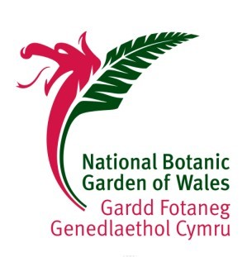

**Christmas Menu**

**2018**

Appetizers

Homemade Welsh Cawl with Crusty Rolls & Local Cheese

Cawl Cennin served with Crusty Rolls & Local Cheese (V)

Glamorgan Sausages with an Onion Compote (V)

Bacon & Black Pudding Bon-Bons on a bed of warm Red Cabbage & Apple Orchard Chutney

Prawn Cocktail with Buttered Brown Bread

Entrée

(accompanied by seasonal vegetables and roast potatoes)

Traditional Roast Turkey with Pork Roulade

Best Welsh Beef and Yorkshire Pudding

Grilled Mackerel with Oyster Mayonnaise & Cucumber Chutney (GF)

Sugar Roasted Vegetable filled Capsicum with Cranberry Glaze (V/GF)

Dessert

Plum Duff & Brandy Sauce (V)

Light Choux Bun filled with Vanilla Cream & Smothered in Toffee Chocolate &

topped with Honey Comb Shards (V)

Chocolate Mint Truffle (V)

Classic Eton Mess (GF/V)

3 Course Meal - £19.95