National Botanic Garden of Wales
Volunteer Role Description

Volunteer Role | Seed Bank Volunteer
Department | Volunteers
Reports to | Volunteer Coordinator

About the Garden
The National Botanic Garden of Wales is a charity dedicated to the advancement of knowledge in the science of plants and
related subjects, and the conservation of plant species. We are the custodian of significant collections and heritage assets for
Wales. As an organisation, we are committed to society’s lifelong learning and we generate and share knowledge and engage
Across diverse communities, government, business and industry. We aim to enhance understanding of the interaction of
people, plants, landscape and the environment in a sustainable future. As part of our diverse research, horticultural and
education work, we advance public appreciation of Welsh culture and heritage and contribute to national efforts to create a
prosperous, resilient, healthier and globally responsible Wales, with a vibrant culture and thriving Welsh language.
Our Vision, Mission and Values
Our Vision
A world that values biodiversity, protects plants and the planet.

Mission
The National Botanic Garden of Wales is dedicated to the research, conservation of biodiversity, to sustainability, lifelong learning, and the enjoyment of the visitor.

Values - CROESO
Collaboration - we succeed through teamwork, sharing knowledge and expertise - our ‘can do’ attitude enables us to be solutions-focused, adaptable and agile.

Respect - We value everyone, we are inclusive, respect differences and treat all with dignity.

Opportunity for All - Everyone has the right to be treated fairly and be offered opportunities.

Exemplar - As a national institution we hold ourselves to professional standards. We celebrate successes and contributions and learn from our failures.

Sustainability - We use sustainability as a lens for decision making to contribute to a globally responsible Wales and ensure our organisation’s longevity.

Openness - We will act with integrity. We take responsibility for our action and inaction and hold ourselves accountable to the people we work with and for.

Description of Role
The National Seed Bank of Wales is housed in the Science Centre at the Botanic Garden, where freezers store seed of Welsh native plant species to ensure their conservation and survival for the future. The seed bank acts as an insurance policy against potential extinctions and a vital resource for research and conservation of Welsh flora, and some of Wales’ most endangered plant species. The Science Team travel all over Wales during the summer months to collect seed from native species to be stored within the seed bank here and at RBG Kew’s Millennium Seed Bank, preserving seed to international standards.

The role of the Seed Bank Volunteer is laboratory-based, supporting the Seed Bank and Engagement Officer to process, clean, count and viability test seed collections before they are dried and stored in the freezer long-term. Carefully cleaning seed and estimating collection sizes is a vital step in the seed banking process, requiring careful handling, patience and attention to detail. Viability testing seed collections involves cut-testing seed under the microscope and setting up and scoring germination tests to assess germination rates of seed collections. This role will also require maintaining accurate records and use of laboratory equipment.

The work is likely to be seasonal, with plenty of processing seed collections in autumn and winter, followed by germination testing. It is likely that volunteering will need to be paused in the summer months while the Science Team are busy doing field work and collecting seed off-site.

This is an exciting opportunity for someone looking to contribute to the conservation of Welsh flora and to gain skills and experience. Training, direction and supervision will be provided by the Seed Bank and Engagement Officer, and by Curator for Seed Bank and Herbarium.

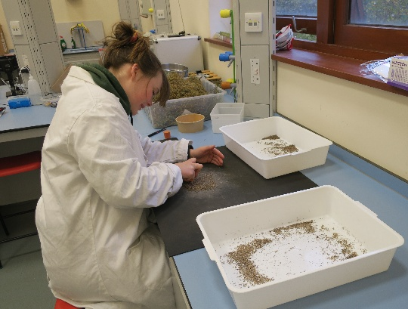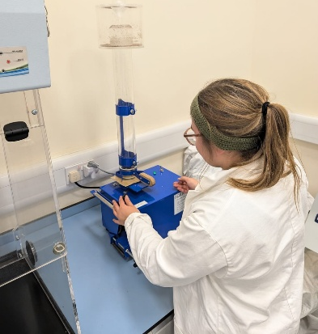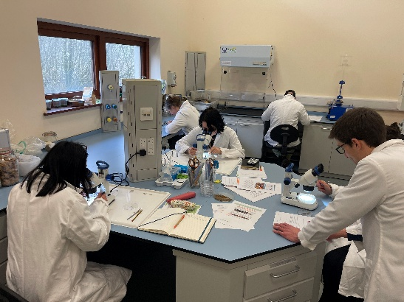

Main Duties and Responsibilities
1 | Processing and cleaning seed collections in the lab to remove chaff and debris, followed by counting and weighing seed to estimate the number of seeds in each collection.
2 | Cut-testing samples of seed from each collection to examine contents and quality of seed. This will require dexterous hands to cut open seeds using a scalpel under the microscope to closely inspect contents.
3 | Sealing and accurately labelling seed collections ready to be stored in the freezer.
4 | Setting up germination tests in a sterile environment and scoring germination weekly to provide baseline data on the viability of seeds within each collection. For selected species, transplanting seedlings into soil.
5 | Maintaining accurate records and entering data on the collections.
6 | Ensure all work is carried out with due regard to health and safety requirements.

Person Specification
 | Essential | Desirable
Knowledge, skills and abilities relevant to volunteering role | - Coordinated and comfortable handling of small objects and seed collections  - Organised with accurate record keeping and attention to detail  - A willingness to do repetitive lab work  - Eagerness to learn  - Reliable in executing tasks according to protocols and staff instructions | - Lab experience  - Ability to use a microscope
Additional requirements | - This role may not be suitable for people with allergies to plants or dust. Personal protective equipment will be provided.  - Minimum six months commitment preferred (one day per week)

